**Project 3 E-Commerce Website of SPORTY SHOES**

**(sportyshoe.com)**

-Abhishek Gangwar

**Project Overview**

For this project, I implement an E-commerce website that sales shoes online using SpringBoot and MySQL database.

The requirements I fulfilled in this project are as follows:

* Database with 5-8 products with productid, productbrand, productname, price.
* Database with 3-5 users with Uid, name, email, password.
* Admin can add,delete,search and update shoes record from database.
* Admin can see all the users details(like: name , email address)
* User can Sign in and Sign up.
* User can see all the products(Shoes) and their price.

**Technology Used**

Java interface, Java, SQL, SpringBoot, RestFull API, JPA

**Analysis**

The first requirement of this project is to provide a database that saves information of all products, we can store all databases involved in this website to the server, and we can consider the user of the website as the client. After analyzing all the requirements, it is pretty simple to come up with the idea to implement the project using client/server architecture. And because our website won’t involve a lot of databases and interactions, I choose to use two tiers, that is the client communicates directly to the server without any third layer between them. The following are some elements in this architecture.

**Components**: database storing information of each shoe and users

**Connectors**: the components in this system are interacted by RestFull API

USER DATABASE

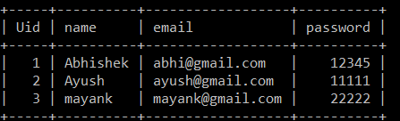

SHOES DATABASE

